LMS Online Quiz Creation

The Quiz is a very powerful activity that can meet many teaching needs, from simple, multiple-choice knowledge tests to complex, self-assessment tasks with detailed feedback.
Creating a new quiz is a two-step process:
- In the first step, you create the quiz activity and set its options which specify the rules for interacting with the quiz.
- In the second step you add questions to the quiz.

1. Create a Quiz Activity
On the LMS course home page, click on “Turn Editing On” Button.
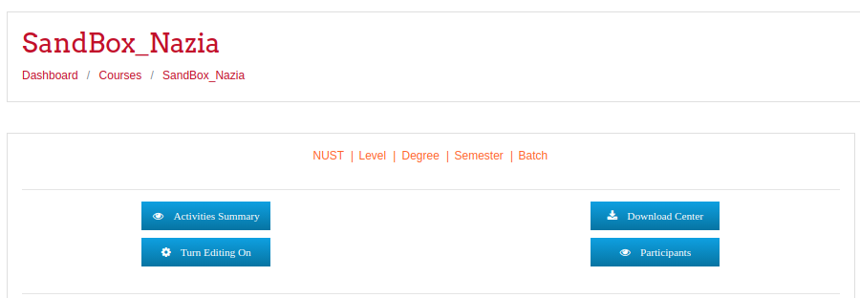

In the relevant section, click Add an activity or resource.
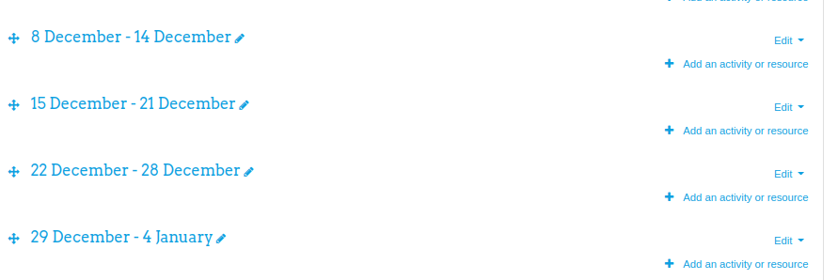
From the list of activities, select Quiz and click Add.

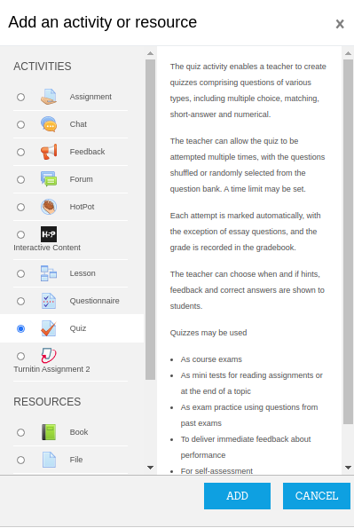

1 General
Add the name of the quiz (which students will click on to access the quiz) and, if desired, a description of what they must do.
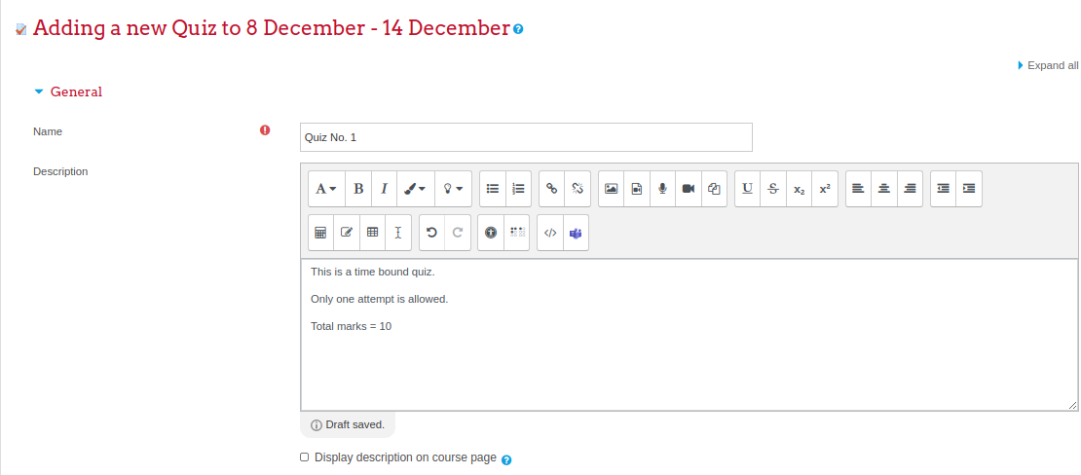

2 Timing
Open the quiz
You can specify times when the quiz is accessible for students to make attempts. Before the opening time the quiz will be unavailable to the students.
They will be able to view the quiz description but will not be able to view the questions. Quiz open and close date and time will also be displayed for students.
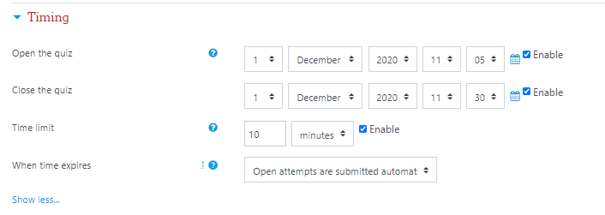
Close the quiz
After the closing time, the students will not be able to start new attempts. If you have explicitly set the option “Open attempts are submitted automatically” in “When time expires” field, the answers would be automatically submitted to the system for grading.
Even after the quiz has closed students will still be able to see the quiz description and review their attempts. (What exactly they will see depends on the settings you choose for “Review options” of the quiz.)
Time limit
By default, quizzes do not have a time limit, which allows students as much time as they need to complete the quiz.
You can set a time duration for a quiz which will be applicable only within the quiz open/close time window.
For the defined time limit, a countdown timer is shown in the quiz navigation block for the students.
When the timer has run out, the quiz is submitted automatically with whatever answers have been filled in so far.
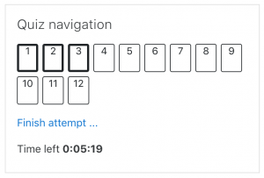

When time expires
There are three options as to what will happen when the time limit is up. Choose the one you need from the dropdown menu:
- Open attempts are submitted automatically (This is the default)
- There is a grace period when open attempts can be submitted, but no more questions answered (students need to explicitly submit in gracetime otherwise the attempt would not be submitted/ marked automatically).
- Attempts must be submitted before time expires, or they are not counted.
If you select "There is a grace period..." then you can check the box to enable the "Submission grace period" and specify a period of time during which learners may still submit the quiz after the time is up.
Note: You can change quiz availability and duration for different groups or users in the Group or User override sections in quiz administration.

3 Grades
Grade category
If you have categories in your gradebook, select the category you wish the quiz to be in there for gradebook display.
Grade to pass
Here you can set a passing grade for the quiz. This may be connected with “Activity completion” and “Conditional activities” such that a student will not be able to access a follow up activity until they have passed the quiz.
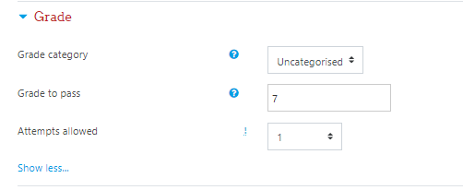
Attempts allowed
Students may be allowed to have multiple attempts at a quiz. This can help make the process of taking the quiz more of an educational activity rather than simply an assessment.

Note: You can change the allowed number of attempts for different groups or users in the Group or User override sections of the Quiz Administration settings block.
Grading method
When multiple attempts are allowed, there are different ways you can use the grades to calculate the student's final grade for the quiz.
- Highest grade - the final grade is the highest (best) grade in any attempt
- Average grade - the final grade is the average (simple mean) grade of all attempts
- First grade - the final grade is the grade earned on the first attempt (other attempts are ignored)
- Last grade - the final grade is the grade earned on the most recent attempt only

4 Layout
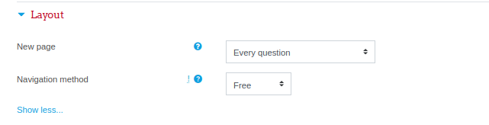
New page
You can stretch the quiz over several pages by limiting the number of questions per page.
If you have many questions that use many high definition images and the server may suffer performance issues, showing only one question per page is easier on the server than showing many (or all) questions in one page.
Navigation method (available by clicking Show More)
Choose Sequential instead of Free, if you want to force the student to progress through the questions in order and not go back to a previous question or skip to a later one.

5 Question behavior
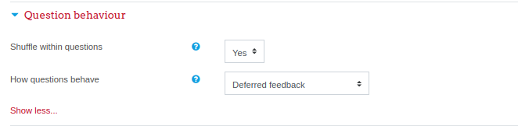
Shuffle within questions
If enabled, the parts making up each question will be randomly shuffled each time a student attempts the quiz, provided the option is also enabled in the question settings. This setting only applies to questions that have multiple parts, such as multiple choice or matching questions.
Deferred feedback
Students must enter an answer to each question and then submit the entire quiz, before anything is graded or they get any feedback.
Note: Only this option needs to be selected for the standard assessments.
Adaptive mode and Adaptive mode (no penalties)
You may allow students to have multiple attempts at the question before moving on to the next question. This behavior requires that the "Whether correct" box is ticked under "During the attempt" in the "Review options" section, at a minimum.
Manual grading
Used for “essay questions” (irrespective of what the quiz is set to) but you can now choose to have every question in the quiz manually graded, if you wish.
Interactive with multiple tries
Used for allowing multiple attempts on the same question (perhaps with a grade penalty). Students answer the question and click the 'Check' button. If the answer is wrong, the student can click the 'Try again' button to try a new response. Importantly, the question definition must contain hints that will be shown after each incorrect attempt, though the hint text can be as minimal as an HTML non-breaking space. Once the student has got the question right, they can no longer change their response. Once the student has got the question wrong too many times, they are just graded wrong (or partially correct) and get shown the feedback. Unless 'Allow redo within an attempt' was enabled in the 'Question behavior' settings of the quiz, they can no longer change their answer. There can be specific feedback after each try the student makes, in addition to overall feedback about incorrect or correct answers and answer choices. The number of tries the student gets is the number of hints in the question definition plus one, with a minimum of three.
Immediate feedback
Similar to interactive mode in that the student can submit their response immediately during the quiz attempt, and get it graded. However, they can only submit one response, they cannot change it later.
Deferred feedback or immediate feedback with Certainty-based marking (CBM)
With CBM, the student does not only answer the question, but they also indicate how sure they are they got the question right. The grading is adjusted by the choice of certainty, so that students have to reflect honestly on their own level of knowledge in order to get the best mark.

6 Review options
This section controls what information students will be shown when they review their past attempts at the quiz, and during the attempt in adaptive mode. It is a matrix with check boxes.
The various pieces of information that can be controlled are:
The attempt
Will show how the student responded to each question.
Whether correct
Displays whether the students response to each question is correct or incorrect.
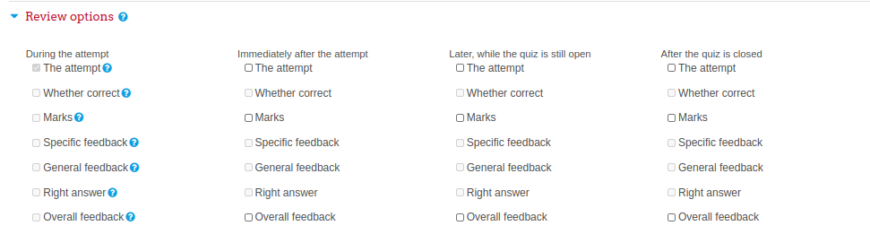
Marks
Reveals the marks awarded to the student and the grade for the quiz.
Specific feedback
Will show the feedback for the response to the answer as set when adding the question to the quiz. Each response to a question can have feedback for both correct and incorrect answers.
General feedback
Displays the general feedback for the whole question as set when adding the question to the quiz. You can use the general feedback to give students some background to what knowledge the question was testing.
Right answer
Reveals the correct answer to each question, whether the student answered correctly or not.
Overall feedback
Displays feedback for the entire quiz as set in the quiz settings.
For each of the above items, you can determine the timeframe when the students will see them:
During the attempt
It is only available when ‘How questions behave’ has been set to ‘Immediate feedback’, ‘Immediate feedback with CBM’ and ‘Interactive with multiple tries’. If set to one of these options then a ‘Check’ button will appear below the answer and when clicked the student will submit that response and then receive immediate feedback.
Immediately after the attempt
It means within 2 minutes of the student clicking "submit all and finish".
Later, while the quiz is still open
It means after 2 minutes, but before the close date (if the quiz does not have a close date, this phase never ends).
After the quiz is closed
It means what it says (you never get here for quizzes without a close date).
Tip: Checking any of the boxes in the timeframe row, will reveal the test to the student. For example, to allow students to see their quiz immediately after taking it but not later, make sure none of the boxes in "Later" or "After" rows are checked. The student will be able to see their grade but not get into the quiz.

7 Appearance
Show the user's picture
It is now possible, when displaying the user's profile picture for proctoring purposes, to choose whether a large image or thumbnail will be displayed.
Decimal places in grades
This option determines how many digits will be shown after the decimal separator when the grade is displayed. A setting of 0 for example means that the grades are displayed as integers. This setting is only used for the display of grades, not for the display or marking of answers.
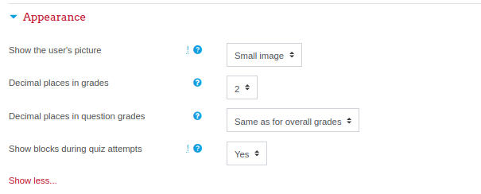
Decimal places in question grades
By default this is an advanced setting. You need to click Show more ... to reveal it. Let’s say, you have a different display of grades for each question compared to the quiz total. For example you may wish to see the total as a whole number, but still show fractional grades for each question.

Show blocks during quiz attempts
Also an advanced setting by default. You can control whether blocks are shown on the page during quiz attempts.

8 Extra restrictions on attempts
Require password
If you specify a password in here then participants must enter the same password before they are allowed to make an attempt on the quiz.
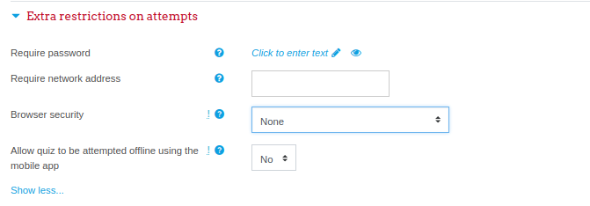
Require network address
You can restrict access for a quiz to particular subnets on the LAN or Internet by specifying a comma-separated list of partial or full IP address numbers. This is especially useful for a proctored (invigilated) quiz, where you want to be sure that only people in a certain room are able to access the quiz.
For example: 192.168. , 231.54.211.0/20, 231.3.56.211
There are three types of numbers you can use (you cannot use text based domain names like example.com):
- Full IP addresses, such as 192.168.10.1 which will match a single computer (or proxy).
- Partial addresses, such as 192.168 which will match anything starting with those numbers.
- CIDR notation, such as 231.54.211.0/20 which allows you to specify more detailed subnets.
Spaces are ignored.

Browser security
Full screen pop-up with some JavaScript security
There is a limit to what the quiz, which runs on a web server, can do to restrict what the student sitting at their computer can do while attempting the quiz. However, this option does what is possible:
Student view of quiz question with full screen popup.
- The quiz will only start if the student has a JavaScript-enabled web-browser.
- The quiz appears in a full screen popup window that covers all the other windows and has no course navigation controls. (However, it is impossible for a web site to create a browser window that cannot be minimized or moved aside.)
- The students are prevented, as far as is possible, from using facilities like copy and paste.

9 Overall feedback
Overall feedback is shown to a student after they have completed an attempt at the quiz. The text that is shown can depend on the grade the student got. Click "Show editing tools" to display the rich text editor, and drag the bottom right of the text box out to expand it.
For example, if you entered:
- Grade boundary: 100%
- Feedback: "Well done"
- Grade boundary: 40%
- Feedback: "Please study this week's work again"
- Grade boundary: 0%
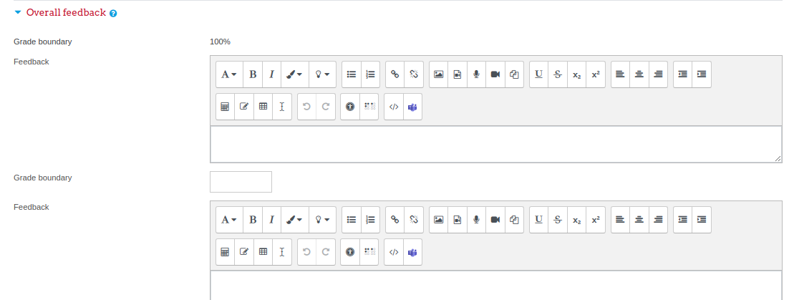
10 Common Module Settings
Restrict Group Access Only:
Expand common module settings and enable group mode for the activity (if you want to assign this quiz to a specific group/ section of the students). After enabling group mode, select the “Separate groups” from the dropdown menu and choose a group from the list of groupings. (Group and groupings creation manual should be consulted for the details about course wise group creation).

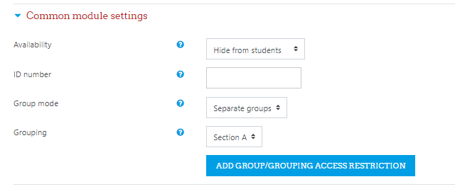
Click the button “Add Group/ Grouping Access Restriction”. This will grey-out the button as shown in the following figure:
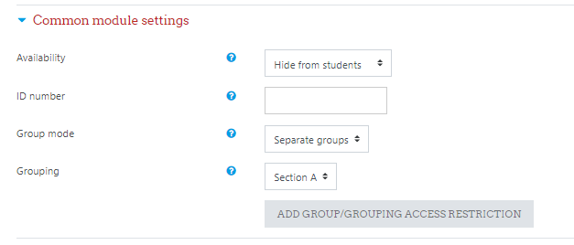

11 Restrict access
Additional restrictions can be applied to the quiz activity using the “Add restrictions” button in the section “Restrict access”.
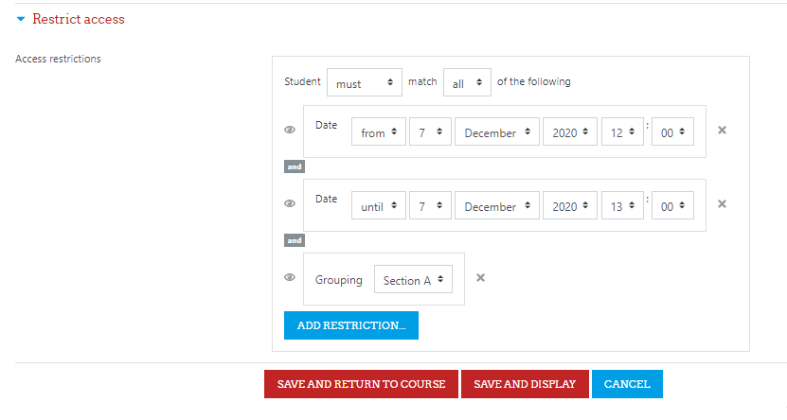
After editing the quiz setting, click on the “SAVE AND DISPLAY” button.

2. Add Questions to the Quiz
Once a quiz has been added to the course and the Quiz settings are established, the teacher can start to build the quiz. The teacher can access the quiz to edit the questions by clicking directly on the Quiz name on the course home page or by clicking "Edit quiz" in the settings menu on the right side of the block (You can also make questions in the Question bank without first creating a quiz. These questions may then be used later.)

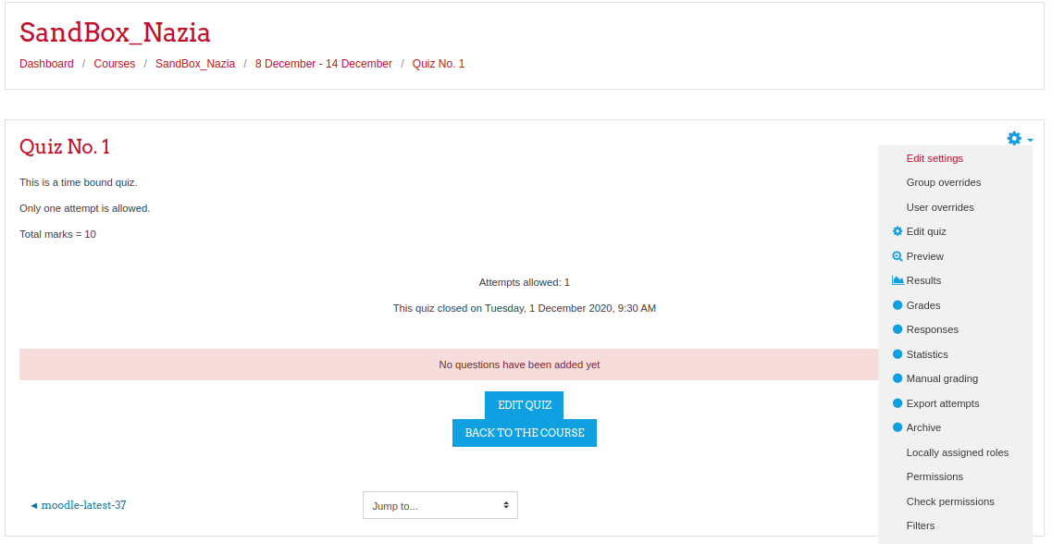

1. Setting total marks of the quiz
- Set the total marks of the quiz using the Maximum grade field and click on the save button.
- Select the “Shuffle” option to display the questions of the quiz to all students in a different sequence.
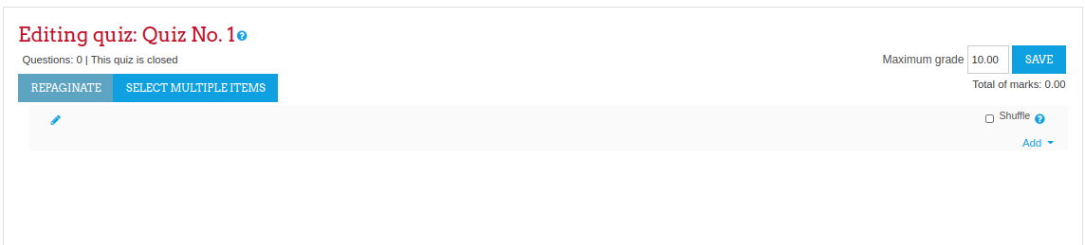

2. Adding questions
Once you have accessed the quiz editing screen as above, you can add questions from a number of locations:
- Click the 'Add' link as in the screenshot below.
- A new question can be created using the “+ a new question” link (the created question will be saved in the question bank).
- An existing question from the question bank can be added in the quiz using the “+ from question bank” link. Random questions from a particular category can be added to the quiz using the link “+ a random question”.
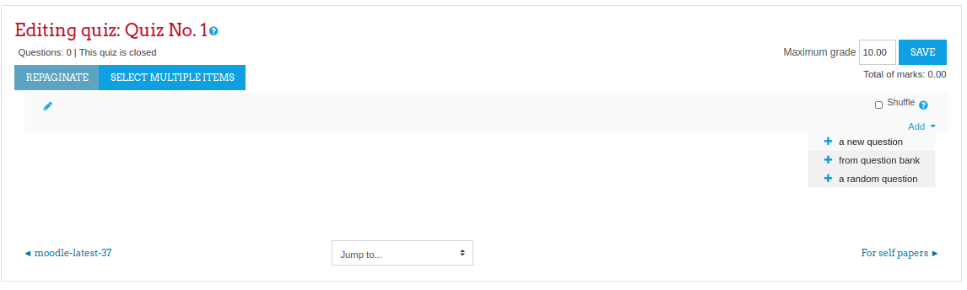

Create a new question
- To make a brand new question, click 'Add' and then '+ a new question'.
- From the next screen, choose the question type you want to add and click "Next" ('When you click on a question type on the left, helpful information appears on the right section.)
- Select a question type and click on the Add button.
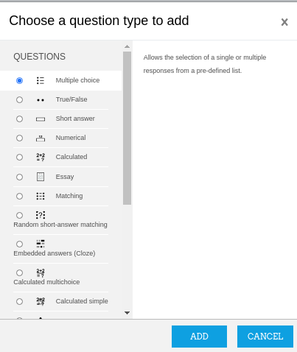

Add a multiple choice question
- Select the question category (default question bank category of the course or any sub-category of the question bank)
- Give the question a descriptive name. You'll use the name to track your questions later so "Question 1" isn't a good idea. The name will be used in the question lists on the quiz editing page or in the lesson as a page title. It will not be shown to the students, so you can choose any name that makes sense to you and possibly other teachers.
- Create the question text. If you're using the HTML Editor, you can format the question just like a word processing document.
- If you want to add a picture to the question. you can click the image icon. This will pop up the Insert Image window. You can choose to upload an image into your files area from this window and then click OK.
- Set the 'default question grade' (i.e. the maximum marks for this question).

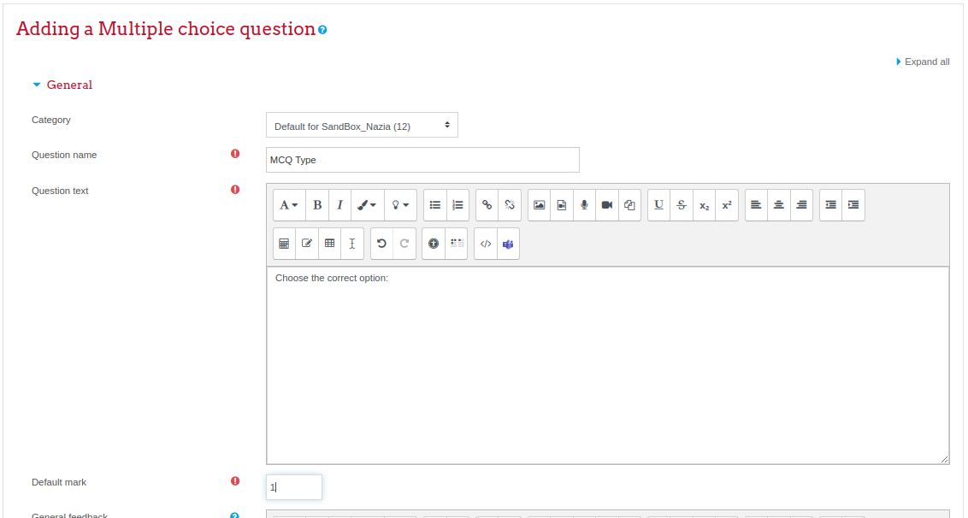

- Choose whether students can only select one answer or multiple answers
- Choose whether to shuffle the answer options
- Choose the number format for answer choices.

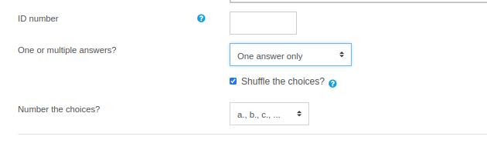
- Write your first answer in the Choice 1 text field. Inserting HTML into this area also makes it possible to add an image or a sound file.
- Select a grade percentage for the answer. This is the percentage of the total points for the question that selecting this response is worth. You can select negative percentages as well as positive percentages. So, selecting a correct response in a multiple answer question may give you 50% of the possible points, while selecting a wrong answer may take away 10%. Note that in a multiple-answer question, the positive grades must add up to at least 100%.
  - Be aware that if you allow multiple answers and have more than a single correct choice, and do not use a negative grade percentage for wrong answers, the students can simply tick all choices and get the full grade.
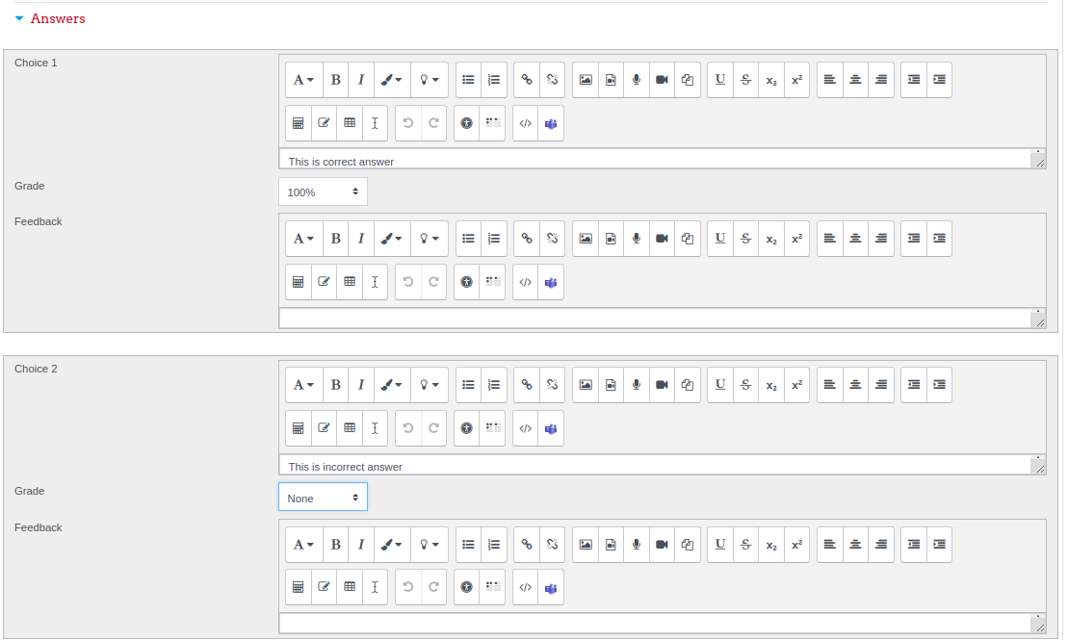
- If you wish, you can add feedback for each response. It may be a bit more work, but it’s good practice to tell the students why each answer is right or wrong using the feedback area. If students know why an answer is right or wrong, they can analyze their own thinking and begin to understand why an answer is correct. Your feedback will only be displayed if you select Show Feedback in the quiz body options.
- Fill in the rest of the response choices in the rest of the form. Any unused areas will be ignored.
- Fill in the overall feedback fields if you wish.
- The 'penalty factor' only applies when the question is used in a quiz using adaptive mode - i.e. where the student is allowed multiple attempts at a question even within the same attempt at the quiz. If the penalty factor is more than 0, then the student will lose that proportion of the maximum grade upon each successive attempt. For example, if the default question grade is 10, and the penalty factor is 0.2, then each successive attempt after the first one will incur a penalty of 0.2 x 10 = 2 points.
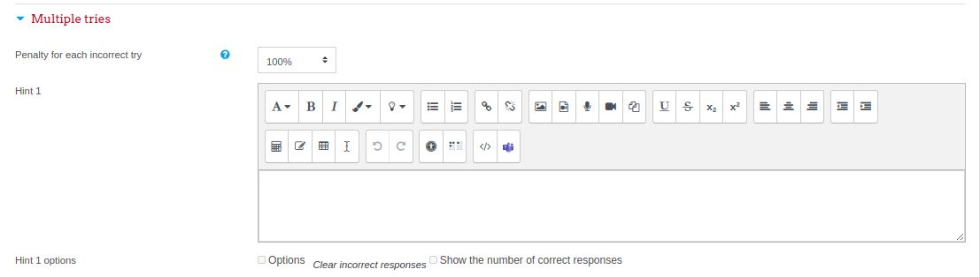

- Select the "Save Changes" button at the bottom of the screen.
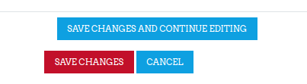
- The question is added into the quiz as well as in the question bank (for future use).
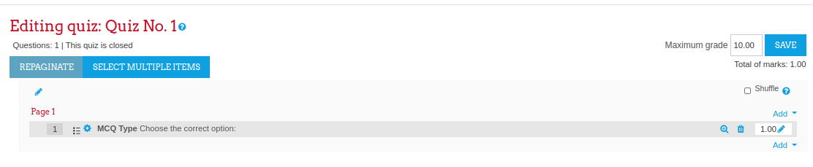
When a question has been created, an icon and words display its type (eg multiple choice). It can be modified by clicking the edit icon (eg ) and previewed by clicking the magnifying glass icon.
As well as deleting individual questions with the delete (bin/trash can) icon, it is possible to delete more than one question by pressing the 'Select multiple items' button and choosing the questions to be removed.
Note:
Question creation process for each question type is explained in the manual “Questions Types”.
Questions import methods using text files are explained in the manual “Import Questions”.
How teacher can preview the quiz after creation is explained in the manual “Quiz Preview”.
How teacher can preview the questions individually is explained in the manual “Questions Preview”.
Quiz override settings are explained in the manual “Quiz Overrides”.
How to access quiz results as explained in the manual “Quiz Results”.
How to review the detailed attempts of students and how to download them is explained in the manual “Review/ Download Quiz Attempt”.

Choose a pre-made question (From the question bank)
- If a teacher made questions in an earlier quiz, these can be added to the current quiz by clicking 'Add' and '+ from question bank'.
- Click the + sign next to one question you want to add. If you have several questions, or you want to add all the questions, tick the box of each question or the top box and then click 'Add selected questions to the quiz'.
- To ensure all previously made questions are available, make sure to tick the boxes "also show questions from subcategories/old questions".
Note:
Questions bank preparation and organization is explained in the manual “Question Bank Organization”.
How to import questions into a question bank using text files is explained in the manuals “Export/ Import Questions in Question Bank”.
________________________

